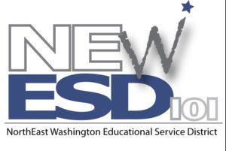
Teacher Evaluation
CONSORTIUM

FORMAL CLASSROOM OBSERVATION

Interview Protocol for a Post-Conference (Reflection Conference)

Teacher _______________________________________ School _______________________________

- In general, how successful was the lesson? Did the students learn what you intended for them to learn? How do you know?

- If you were able to bring samples of student work, what do those samples reveal about those students’ levels of engagement and understanding?

- Comment on your classroom procedures, student conduct, and your use of physical space. To what extent did these contribute to student learning?

- Did you depart from your plan? If so, how and why?

- Comment on different aspects of your instructional delivery (e.g., activities, grouping of students, materials and resources). To what extent were they effective?

- If you had an opportunity to teach this lesson again to the same group of students, what would you do differently?

